Spring Data JPA - Quick
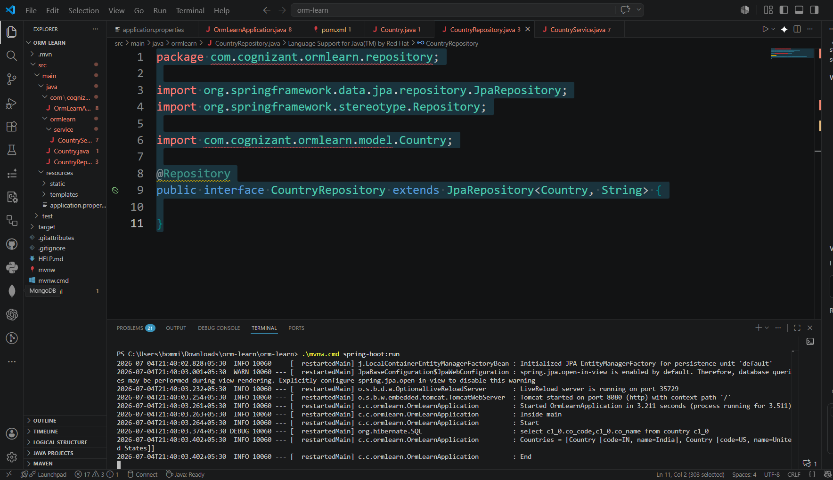
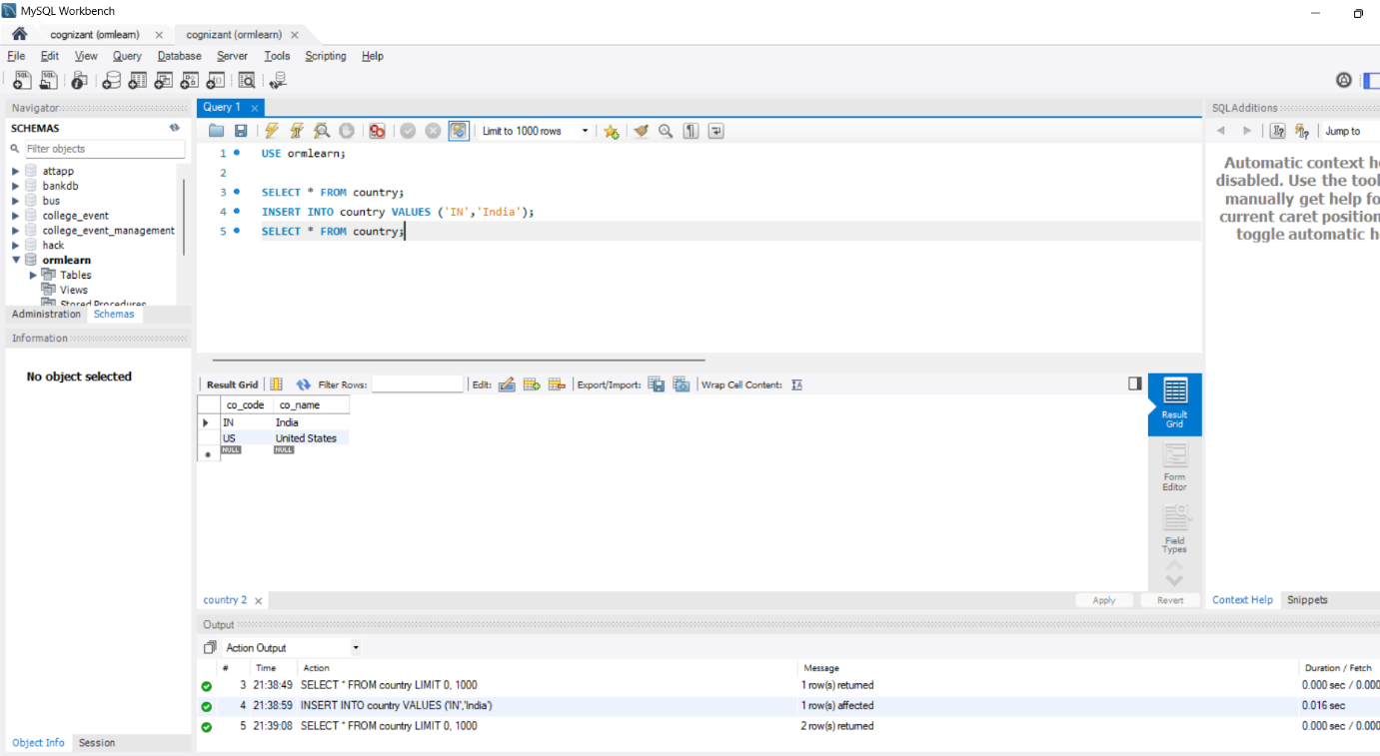

Difference between JPA, Hibernate and Spring Data JPA
- JPA (Java Persistence API)
- JPA is a specification.
- A specification means a set of rules or guidelines.
- It defines how Java objects should be stored and retrieved from a database.
- Important
- JPA does not contain code to connect to the database.
- It only defines the standard way to perform database operations.

- Hibernate
  - Hibernate is an ORM (Object Relational Mapping) framework.
  - It implements JPA.
  - Hibernate converts Java objects into SQL statements and communicates with the database.
  - Real-life example
  - Using the same house example:
- Blueprint = JPA
- Workers = Hibernate
  - The workers build the house by following the blueprint.
  - Similarly, Hibernate performs the database operations by following JPA rules.
- Spring Data JPA
- Spring Data JPA is a Spring Framework module.
- It uses JPA (and an implementation such as Hibernate) and removes most of the repetitive code.

